© 2022 ILSI Europe
The statements, opinions, and advertisements in this publication, form or calculation workbook are solely those of the individual authors, contributors, editors, or advertisers, as indicated. Those statements, opinions, and advertisements do not reflect any endorsement by ILSI Europe. Unless otherwise specified, ILSI Europe disclaims all responsibility or liability for such material.
This Incidents Form is prepared by ILSI Europe Food Allergy Expert Group on Allergen Quantitative Risk Assessment (QRA) as part of ""Practical Guidance on the Application of Food Allergen Quantitative Risk Assessment"". For more information and guidance on how to use the incidents form see: here.
This publication is licensed under the Creative Common Attribution 4.0 International (CC BY 4.0). This license allows reusers to distribute, remix, adapt, and build upon the material in any medium or format, so long as attribution is given to the creator. The license allows for commercial use.
“A Global Partnership for a Safer, Healthier World ®”, the International Life Sciences Institute (ILSI) logo image of concentric circles, the word mark “International Life Sciences Institute”, as well as the acronym “ILSI” are trademarks of the International Life Sciences Institute and licensed for use by ILSI Europe. The use of trade names and commercial sources in this document is for purposes of identification only and does not imply endorsement by ILSI Europe.
For more information about ILSI Europe, please contact
ILSI Europe a.i.s.b.l.
Avenue E. Mounier 83, Box 6
B-1200 Brussels
Belgium
Phone: (+32) 2 771 00 14
E-mail: publications@ilsieurope.be
www.ilsi.eu

This Incident Form is prepared by ILSI Europe Food Allergy Expert Group on Allergen Quantitative Risk Assessment (QRA) as part of ""Practical Guidance on the Application of Food Allergen Quantitative Risk Assessment". The following form may be adapted for use.
For more information and guidance on how to use the incident form see the section 4. Management of Incidents.
1 General Information & Assessment Summary
Assessment Team
Assessment Date
Incident Dates
Type of incident | Upstream  In-house  Downstream | Source of information  ☐  ☐  ☐ | Point of cross-contact  ☐  ☐  ☐
Foodstuff and allergen(s):
Market(s): | Country, region, retailer etc.
Product disposition: | Number of consumer units on hold, in distribution, at market etc.
Risk to consumers: | - There is a risk to allergic consumers  - Risk within agreed limits of acceptability  - Not currently possible to determine
Quality of Evidence: | High, medium, or low
Scale of risk: | e.g., does identified risk relate to ingredient / labelling error, or concerns incorrect PAL statement, or concerns allergen presence in a product that claims absence?  What is the frequency of UAP?  Is there an excessive and clear risk to consumers?
Opportunity for refinement: | Next steps possible to improve the assessment
Regulatory situation: | Description of any non-compliance
Proposed mitigation & actions, next steps: | Proposed action plan, based on risk and quality of evidence, including recommendation to risk managers, contact with authorities or patient organisations etc.

2 Incident Flow Chart
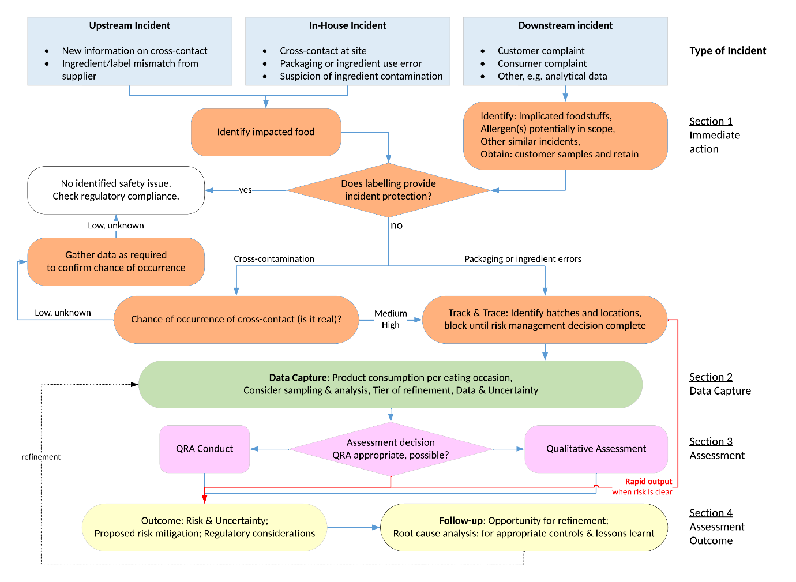

3 Assessment Matrix
Section 1: Immediate Action
Identity of foodstuff implicated
Allergen(s) implicated
Supporting information
Does labelling provide incident protection, or exacerbation ? | See explanation in 4.1.5
Summary if relevant of consumer complaints | Including any trend in consumer complaints
Chance of Occurrence of Cross-Contact
See ‘Core concepts’ Section 5.1.1 for a description of ‘Chance of Occurrence’
Chance of Occurrence | Notes
☐ High or known to have happened
☐ Medium
☐ Low or unknown
Track & Trace
Current status
Degree of success of T&T
Implicated batch no.s, production dates
No. Packs (consumer units) implicated
No. Packs Held
No. Packs in distribution
No. Packs at consumer market
Shelf-life remaining
Other supporting information

Section 2: Data Capture
Consumption
See ‘Core concepts’ section 0 for guidance on consumption estimates
Pack size (consumer unit) (g) | Meal preparation | Portion size (g) | Quantity of implicated food eaten per consumption event (g)
 | How pack is used | See explanation in Core concepts section | possible range & description of uncertainties
the ‘Tier of Refinement’
Tier | Description |  | Source of Data
☐ Tier 1  ‘Theoretical’ | Concern has been raised on UAP but there is no physical evidence of cross-contact at the product site or supply chain in question. |  | No data available, only ‘reverse’ QRA possible (see Core concepts).
☐ Tier 2  ‘Informed’ | Some physical evidence of UAP of the specific supply chain in question, high uncertainty in quantification. |  | The data available for QRA is based on ‘reasonable worst case’ assumptions, e.g., hang-up estimation (see 5.2.3 carry-over guidance).
☐ Tier 3  ‘Data-driven’ | Physical evidence of UAP at the production site or specific supply chain in question, with indirect quantification possible. |  | The data available is from upstream in the supply chain, for example on a purchased ingredient.
☐ Tier 4  ‘Verified’ | Physical evidence of UAP at the production site or specific supply chain in question, with direct quantification possible. |  | data is available on finished product as presented to consumer, or in case of mis-labeling or ingredient error there is clarity on the allergen content of the food.

Characteristics of UAP: Data & Uncertainty
See ‘Core concepts’ Section 5.1.2 for a description of UAP Characteristics and Uncertainty
Characteristics |  | Uncertainty | Data & Notes
A  Form of UAP | ☐ Amorphous | 1 ☐ High | -------------------------------------------------------------------  Note: If ‘unknown’, assessment should be based on both amorphous and particulate, until refined information is available.
 | ☐ Particulate | 2 ☐ Medium
 | ☐ Unknown  (please mark uncertainty as ‘high’) | 3 ☐ Acceptable
B  Distribution of UAP | ☐ Homogeneous | 1 ☐ High | -------------------------------------------------------------------  Note: If ‘unknown’, assessment should be based on both hetero’ and homogeneous, until refined information is available.
 | ☐ Heterogeneous | 2 ☐ Medium
 | ☐ Unknown  (uncertainty is always ‘high’) | 3 ☐ Acceptable
C  Frequency of UAP  (how often the cross-contact is happening) | ☐ Isolated | 1 ☐ High | ---------------------------------------------------------------------  Note: If ‘unknown’, assessment should assume UAP is ‘regular’.
 | ☐ Intermittent | 2 ☐ Medium
 | ☐ Regular | 3 ☐ Acceptable
☐ unknown
(uncertainty is always ‘high’)
D  Concentration of UAP | 1 ☐ Unknown or Estimate (not analytical). Note: see carry-over guidance 5.2.3 |  | Provide data:  Describe suitability of analytical data:  -------------------------------------------------------  Note: If ‘unknown’, assessment can only be qualitative. More information is needed before QRA can be performed.
 | 2 ☐ Analytical, point data
3 ☐ Analytical, data range.

In the case of mis-labeling or wrong ingredient used, where there is knowledge on amount of allergen present, mark as 3.
Overall data uncertainty (sum of A-D) |  | 4-7 ☐ High  8-10 ☐ Medium  >10 ☐ Acceptable | Notes

Section 3: Assessment
Assessment Decision |  | Notes: rationale for selected option
It is beyond doubt that there is an unacceptable risk, no further assessment required | ☐
Uncertainty is too large to enable an assessment, further information required | ☐
QRA is appropriate but not possible without further information, qualitative assessment only | ☐
QRA is appropriate and possible | ☐
QRA Metrics (for ‘screening’ and ‘deterministic’ QRA)
See ‘Core concepts’ section 5.4 for calculation guidance
Description of the exposure scenario
In case an Action Level (ppm) was calculated to compare to concentration in food (ppm), what was is the Action Level ? | Action Level = | Conc in food =
In case exposure of allergic consumer was calculated (mg) to compare to RfD (mg), what was the exposure ? | Appropriate RfD = | Consumer exposure =
Description of the calculation
In case of higher level calculations, eg probabilistic, population level, provide details

Section 4: Assessment Outcome
Key Output | Evidence
Risk Assessment Outcome | There is a risk to allergic consumers  Risk within agreed limits of acceptability  Not currently possible to determine | ☐  ☐  ☐
Proposed risk mitigation (in case of risk to allergic consumers)
Need to contact external agencies | Eg authority, patient org ?
Method of assessment | Qualitative  Quantitative (QRA)  Not currently possible to assess | ☐  ☐  ☐
Regulatory implications
Product Presentation
Describe aspects of product presentation that may modify the risk | For example, partial risk mitigation due to existing PAL warning, or exacerbation due to use of a free-from claim.  Frequency of contamination as an indicator of scale of risk.
Quality of Evidence Framework |  |  | score
Tier of refinement | Tier 1 – theoretical  Tier 2 – informed  Tier 3 – data-driven  Tier 4 – verified | ☐  ☐  ☐  ☐ | 1  2  3  4
Chance that cross-contact is occurring | Low or unknown  Medium  High or known to have happened | ☐  ☐  ☐ | 1  2  3
Overall data uncertainty | High uncertainty  Medium uncertainty  Acceptable uncertainty | ☐  ☐  ☐ | 1  2  3
Quality of Evidence | 9 – 10 : high quality evidence  6 – 8 : medium quality evidence  5 and below : low quality evidence | ☐  ☐  ☐
Opportunities for Refinement
If there is sufficient time available for refinement, describe data needed and next steps
Root Cause Analysis & Corrective Action
Describe root cause, corrective action

For more information and key references regarding the fundamentals of how allergen RfDs are derived from oral food challenge data and subsequen t dose-distribution models, as well as what might constitute an appropriate RfD see Box Reference Doses in the Guidance available here.

